Ferramentas

. Node.js

. Git

. Visual Studio Code

. React Developer Tools
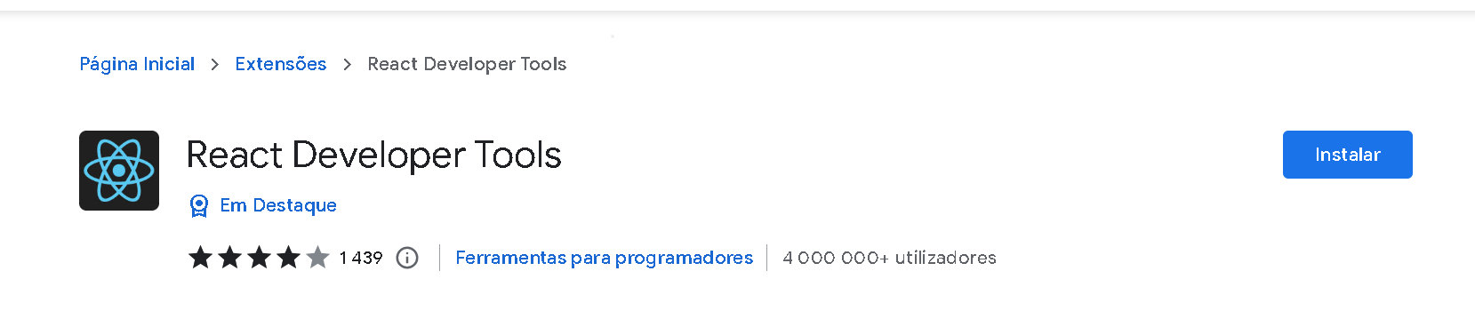

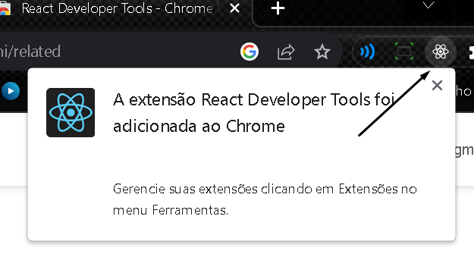

Instalando o plugin es7 react:

